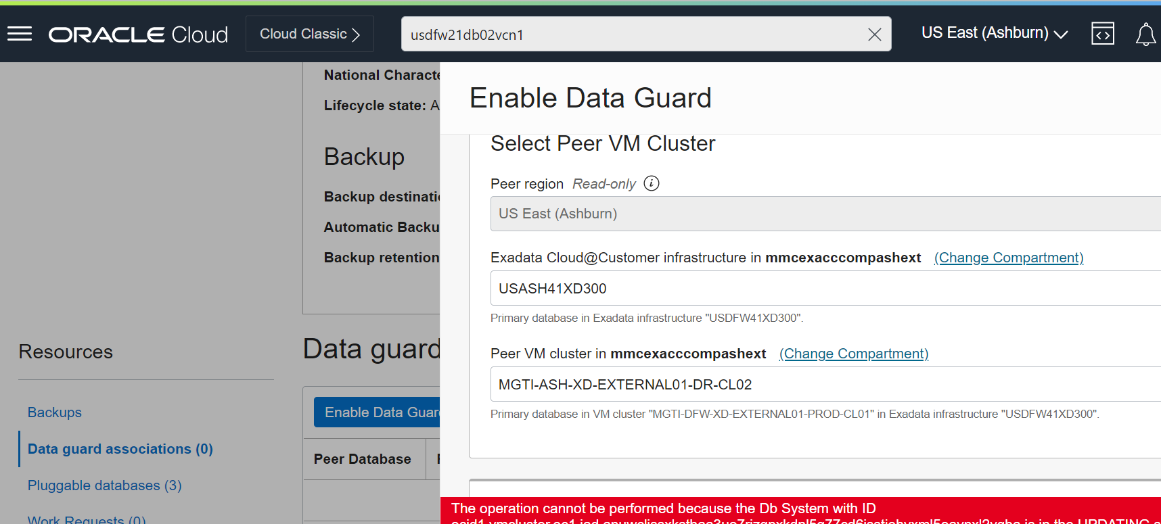

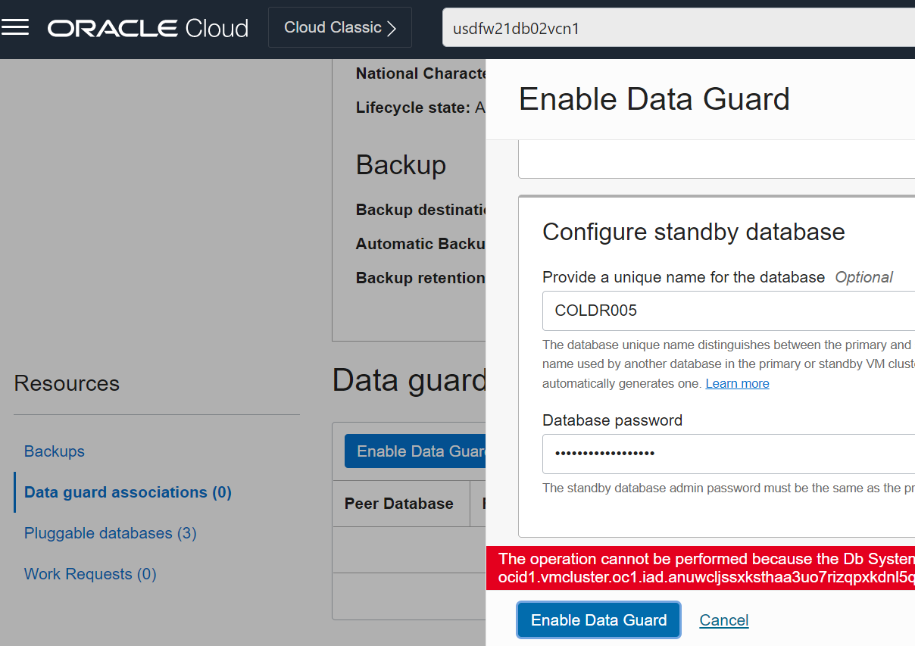

Error:

Database job: Failed. CDG-50101 : DataGuard provisioning failed at stage VERIFY_DG_PRIMARYPlease refer accompanying errors for failure